

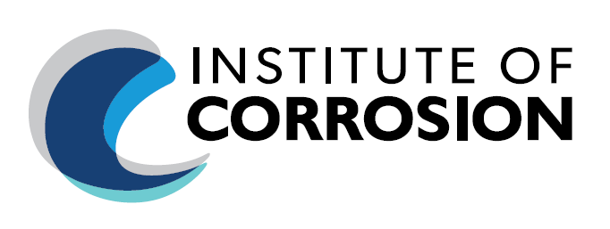

**Joint Meeting**

**ICorr Aberdeen Branch / EI - The Energy Institute**Palm Court Hotel, 81 Seafield Rd, Aberdeen AB15 7YX

**Tuesday 30th January 2023, Start Time: 18:00 (UK Time)**

**In-Person Presentation only.**

**For Registration (use LINK below):**

[Event Registration](https://docs.google.com/forms/d/e/1FAIpQLSfNqy4QeIHmqEoTCCo6tHa4DiOPN24xWGbVRxIF-GP-VkZbrA/viewform?usp=sf_link)

**Event is Free of Charge to attend.**

**Applying Materials Experience from Oil and Gas Production To Carbon Capture And Storage In North East Scotland**

**Speaker:**  **Dr. Steve Paterson, Arbeadie Consultants Limited**

**Event Programme:**

18.00 – 18:30: Arrival / Networking / Refreshments  
18:30 – 18:40: Introductions; EI and ICorr   
18:40 – 19:20: Technical Presentation  
19:20 – 19:30: Q&A   
19:30 – 19:40: Closing Remarks; EI and ICorr

**The Talk:**

**Applying materials experience from oil and gas production to carbon capture and storage in North-East Scotland**

Carbon Capture and Storage (CCS) is a key technology to mitigate emissions from large-scale fossil fuel use. During transport and injection of the CO2 separate liquid phases may form depending on the phase envelope and CO2 composition. These phases can comprise of water or reaction products including strong acids and elemental sulphur. The type of liquids formed and shifts in the phase envelope can significantly influence materials integrity including fracture, corrosion, and degradation of polymers. Guidance based on experience gained from the oil and gas sector will be used to propose a process for materials selection and corrosion control that can address the specific requirements of a CCS project. The presentation will be placed in context with the historical development of a carbon capture and storage opportunity offshore Aberdeen.

**Biography**: Steve graduated from Imperial College London with a B.Sc.(Eng.) and Ph.D in Metallurgy. He has over 40 years’ experience in the oil and gas industry, mostly with Shell. His final position at Shell was Principal Technical Expert for Upstream

Materials. He was primarily involved in materials, corrosion, welding, inspection and integrity management, and has worked in the UK, Netherlands, Norway, Middle East and Malaysia.

He has been involved in several CCS projects during his career and has published papers on materials selection for CCS.

Steve is currently an independent materials & corrosion adviser with Arbeadie Consultants based in Banchory near Aberdeen, UK; and also an external lecturer in Materials and Corrosion Management at Robert Gordon University in Aberdeen.

He was awarded the Institute of Corrosion Paul McIntyre Award in 2019A and EFC Fellowship in 2023.

**Additional Information:**

* Registration information will be shared with our Branch volunteers to help facilitate the event.

**For Continuing Professional Development (CPD) or to join our Mailing List,**

**request by email to:** [ICorrAbz@gmail.com](mailto:ICorrAbz@gmail.com)

**Event Sponsors (ICorr):**

We gratefully acknowledge all our loyal Branch and Sustaining Sponsors:

