

**ICorr Wales & South-West England Branch**

**Inaugural Mtg.**

**Venue:** R-TECH Materials, Testing House, Kenfig Industrial Estate,

Margam, Port Talbot, SA13 2PE

**Thursday 21st March 2024, Start Time: 11:30am (UK)**

**In-Person Presentation only.**

**For Registration (use LINK below):**

[Event Registration](https://forms.office.com/Pages/ResponsePage.aspx?id=40_5Q8KIqEaLPhxNPkGAJUfG04cav4ZMu5AkePJgmvdUNzlNNkc0TjRYMEMwR1RGWTJYRVlMWVFVSS4u)

**Event is Free of Charge to attend.**

**Microbiologically Induced Corrosion –** [**real world failures and how to prevent them**](http://www.etde.org/etdeweb/details.jsp?query_id=1&page=0&osti_id=20014071)

**Speakers:**  **Sarah Bagnall, R-TECH Materials**

**Gareth Williams, ECHA Microbiology**

**Event Programme:**

11.30 – 12:00: Arrival / Networking / Refreshments  
12:00 – 12:10: Introductions / AGM   
12:10 – 12:40: Technical Presentation – Sarah Bagnall

12:40 – 13:10: Technical Presentation – Gareth Williams  
13:10 – 13:20: Q&A   
13:20 – 14:00: Site Tour (PPE will be provided)

**The Talk:**

**Microbiologically Induced Corrosion –** [**real world failures and how to prevent them**](http://www.etde.org/etdeweb/details.jsp?query_id=1&page=0&osti_id=20014071)

Microbiologically Induced Corrosion (MIC) affects numerous industries and a wide range of materials. MIC is responsible for many incidents where failure has occurred shortly after commission often leaving the end user perplexed when inspection reports show the equipment to be defect free following manufacture/installation. The use of more exotic alloys has been a common rectification to the problem, though MIC issues have still been encountered.

The first presentation, by Sarah Bagnall, provides an insight into the mechanism of MIC and how the mechanism is identified, the common triggers, affected materials, and a number of case studies from various industries. The second presentation, by Gareth Williams, provides some of the microbiological laboratory-based studies ECHA have conducted to investigate prevention strategies in specific Marine systems.

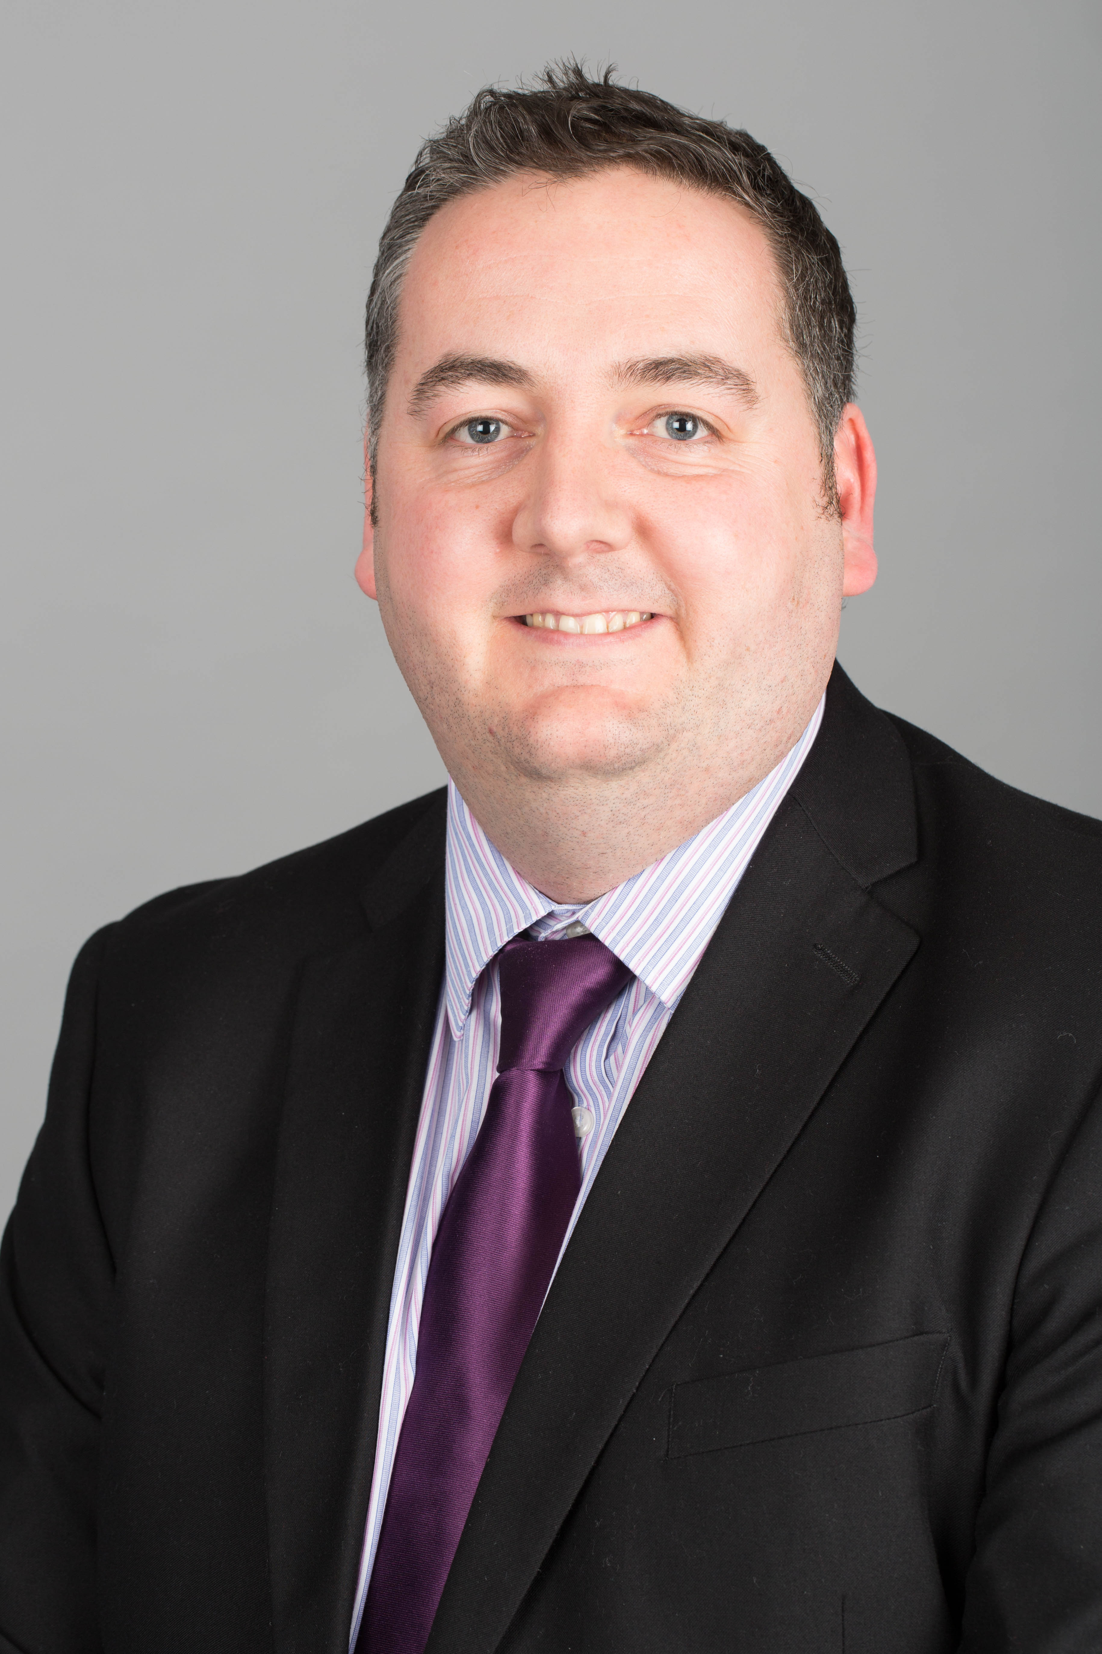

|  |  |
| --- | --- |
| **Sarah** is a materials engineer and Chartered Engineer specialising in failure analysis particularly for the petrochemical, process and power generation industries. With over 600 failure investigations conducted, Sarah has broad experience with a wide range of engineering components, metallic and non-metallic materials, and industries. Sarah has extensive expertise in corrosion of a wide range of materials, particularly for the chemical processing and petrochemical industries. | **Gareth** is a PhD microbiologist and has been working at ECHA Microbiology since 2010. He provides consultancy for ECHA’s customers in the petroleum, aviation, marine and engineering industries in response to microbiological spoilage and corrosion incidents.  Gareth also supports and hosts many of ECHA’s training courses worldwide. Gareth is also active on technical committees, including the Energy Institute Microbiology Committee, IATA Technical Fuels Group, ASTM D02 and E35, and AMPP SC22 Biodeterioration. |

**Sarah Bagnall**, R-TECH Materials and **Gareth Williams**, ECHA Microbiology

**Additional Information:**

* Registration information will be shared with our Branch volunteers to help facilitate the event.
* Registration will close on Monday 18th March.

**For Continuing Professional Development (CPD) or to join our Mailing List,**

**request by email to:** [**swchair@icorr.org**](mailto:swchair@icorr.org)

Institute Professional Memberships are available at: [https://www.icorr.org/grades-and-benefits-of-individual-membership-2/](https://eur01.safelinks.protection.outlook.com/?url=https%3A%2F%2Fwww.icorr.org%2Fgrades-and-benefits-of-individual-membership-2%2F&data=05%7C02%7Cstephen.tate%40external.totalenergies.com%7C87529efb050043ff91cf08dc1534adb9%7C329e91b0e21f48fba071456717ecc28e%7C0%7C0%7C638408563213048447%7CUnknown%7CTWFpbGZsb3d8eyJWIjoiMC4wLjAwMDAiLCJQIjoiV2luMzIiLCJBTiI6Ik1haWwiLCJXVCI6Mn0%3D%7C3000%7C%7C%7C&sdata=66fjYaNY4tpIhoUsO9%2Bly4wMb8i1xF9ATvo4a9keJqM%3D&reserved=0)

Free Student Memberships are available at: [https://www.icorr.org/free-student-membership/ [icorr.org]](https://eur01.safelinks.protection.outlook.com/?url=https%3A%2F%2Furldefense.com%2Fv3%2F__https%3A%2Fwww.icorr.org%2Ffree-student-membership%2F__%3B!!Ie6nUkZk!vzLhUEglr1QVONFJEvMFYSpW1hjyoDG6zl1LJZ_xtKi_nWnIrHaDW8JbKHXbxklSMztJDR19bGozkNKjkJbdOmGhor22gbQ6Hx8TVxPGVcg%24&data=05%7C02%7Cstephen.tate%40external.totalenergies.com%7C8fe9629b9753446ca30708dc15bd4bfe%7C329e91b0e21f48fba071456717ecc28e%7C0%7C0%7C638409150286493786%7CUnknown%7CTWFpbGZsb3d8eyJWIjoiMC4wLjAwMDAiLCJQIjoiV2luMzIiLCJBTiI6Ik1haWwiLCJXVCI6Mn0%3D%7C3000%7C%7C%7C&sdata=kw6MzxKdXw7Da89E7LN9VECBonW6IbJ3QFruOc15TnM%3D&reserved=0)